**School Of Information Technology**

**IT2553 Data Structure and Algorithm**

|  |  |
| --- | --- |
| **Admin No & Team Members Name:** | 201520M: Eden Will Sng Jin Xuan |
| **PEM Group:** | SF2102 |
| **Module:** | IT2553-02 |
| **Assignment:** | Practical 03 |

Bi

Base-2 logarithm of n or log2(n)

Bii

The logarithm function grows very slowly. Logarithm are the inverse of exponetntial which grow very rapidly an example can be seen here.

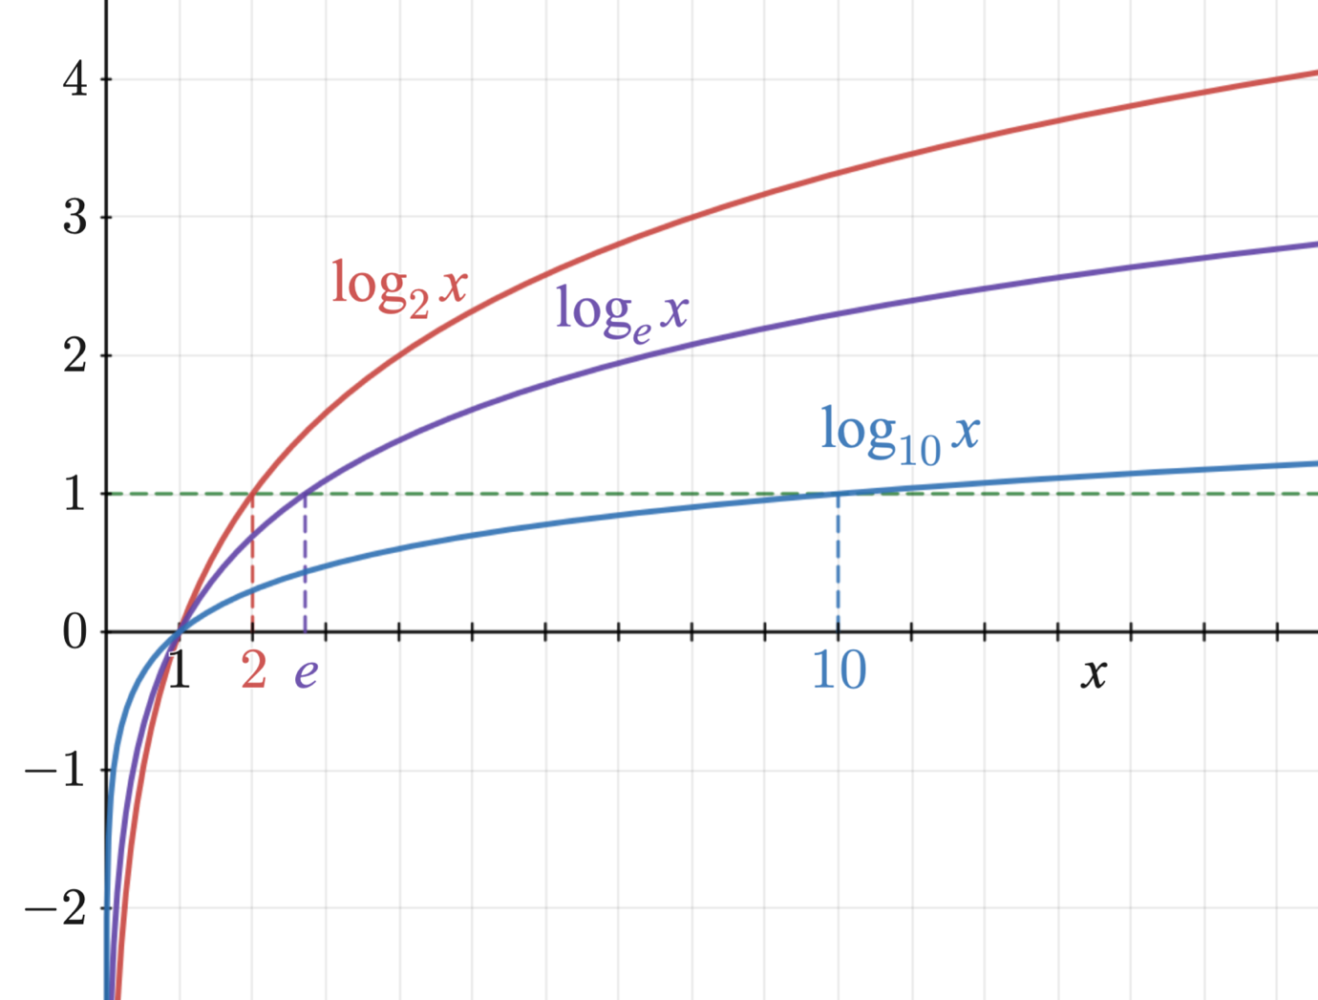

Logarithmic expression on a graph

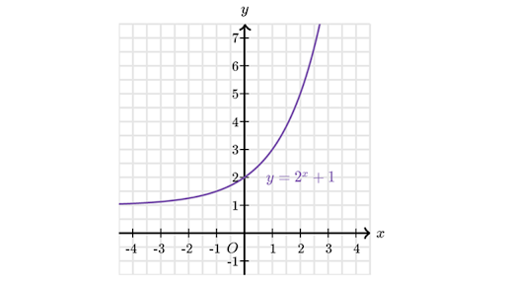

Exponential expression

Biii

1. Let min = 0andmax = n-1.  
2. If max < min, then stop: target is not present in array. Return -1. 3. Compute guess as the average of max and min, rounded down (so that it is an integer).  
4. If array[guess] equals target, then stop. You found it! Return guess.  
5. If the guess was too low, that is, array[guess] < target, then set min = guess + 1.  
6. Otherwise, the guess was too high. Set max = guess – 1.  
7. Go back to step 2